**DAILY ONLINE ACTIVITIES SUMMARY**

|  |  |  |  |  |  |  |  |  |
| --- | --- | --- | --- | --- | --- | --- | --- | --- |
| **Date:** | **31-05-2020** | | | | | **Name:** | **pallavi** | |
| **Sem & Sec** | **6th A** | | | | | **USN:** | **4al17cs056** | |
| **Online Test Summary** | | | | | | | | |
| **Subject** | |  | | | | | | |
| **Max. Marks** | |  | | **Score** | | |  | |
| **Certification Course Summary** | | | | | | | | |
| **Course** | **Robotic process automation** | | | | | | | |
| **Certificate Provider** | | | **GUVI** | | **Duration** | | | **3hr** |
| **Coding Challenges** | | | | | | | | |
| **Problem Statement:**  **1. Write a c program to convert decimal number to binary.**  **2. Write a c program to print alphabet triangle.**  **3. Write a python program to print the multiplication table of number.** | | | | | | | | |
| **Status:completed** | | | | | | | | |
| **Uploaded the report in Github** | | | | | **yes** | | | |
| **If yes Repository name** | | | | | <https://github.com/pallavi056/DAILY_STATUS> | | | |
| **Uploaded the report in slack** | | | | | **yes** | | | |

Certification Course Details:

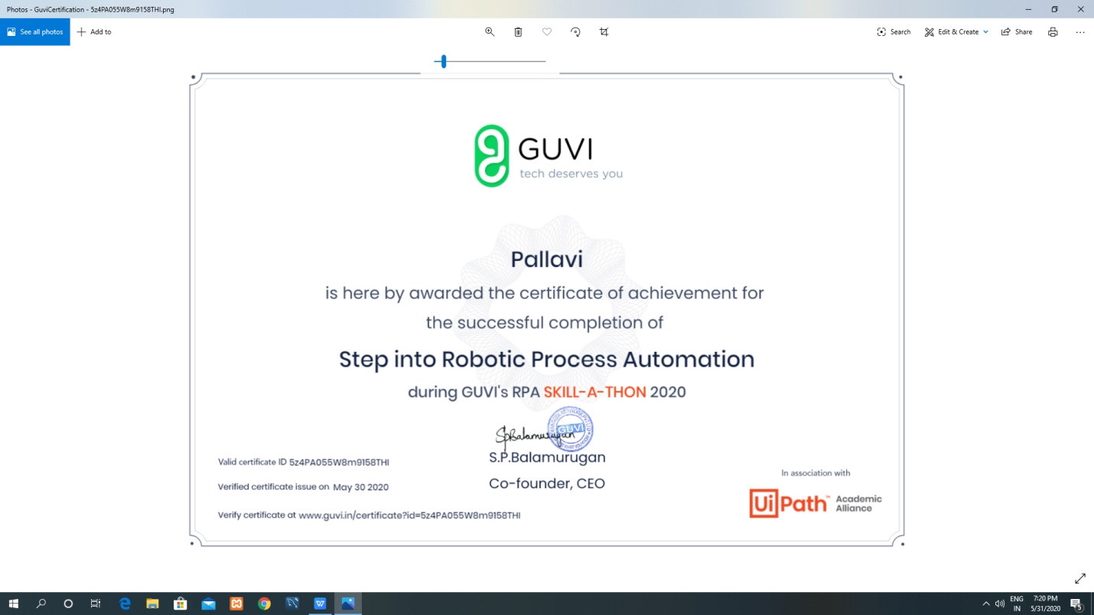

Coding Challenges Details:

[https://github.com/pallavi056/DAILY_STATUS/tree/master/31-05-2020/ONLINE%20CODING](https://github.com/pallavi056/DAILY_STATUS/tree/master/31-05-2020/ONLINE CODING)